Assignment 1 (09/02/2026)
Assignment Name : Internet Explorer
Description : Draw and explain the client-server architecture and trace what happens when you open a website.
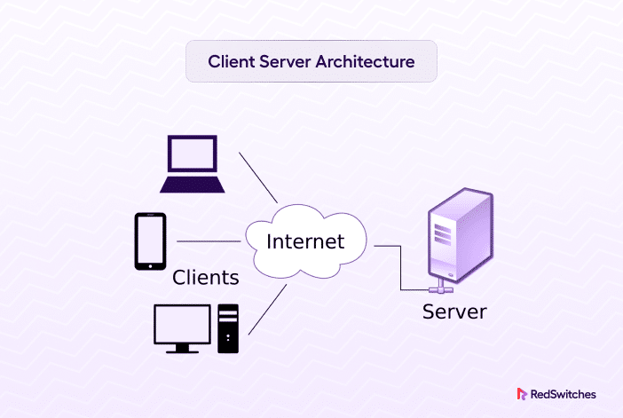
Client-server architecture is a foundational model for web interactions, where clients (like browsers) request resources from servers. Opening a website involves a sequence of network steps following this model.
Architecture Overview
Client-server architecture divides responsibilities: the client handles user interface and input, while the server manages data storage, processing, and responses. This follows a request-response pattern over networks like the internet, enabling scalability as one server serves many clients.
Diagram Description
Imagine a simple diagram with two main boxes connected by bidirectional arrows over a network cloud:
- Left: Client (e.g., web browser like Chrome), showing presentation layer (UI).
- Right: Server (e.g., Apache/Nginx), with layers for business logic and data access.
Arrows represent HTTP requests from client to server and responses back.
Website Opening Process
- User enters URL (e.g., www.example.com) in browser.
- Browser performs DNS lookup to resolve domain to IP address.
- Browser establishes TCP connection (handshake) to server's IP on port 80/443.
- Browser sends HTTP/HTTPS GET request with headers (e.g., User-Agent).
- Server processes request: authenticates, queries database if needed, generates HTML/CSS/JS.
- Server sends response (status 200 OK, content).
- Browser renders page, fetches additional resources (images, scripts) via follow-up requests.​

